Yr 12 General Integrated Science
TASK 8 – Investigating energy content in fuels

Fuels are used in a variety of applications depending on the type of fuel.
Fuels generally are combustible chemicals that react with oxygen to produce carbon dioxide, water and energy.
Fuels contain different energy values according to their chemical structure. Kerosene is used in lamps; alcohol is used in some car engines; petrol is used in car engines and wax is used in candles to name a few.

To find the amount of energy in a certain fuel, a certain amount of fuel is burnt and the flame from the combustion is used to heat up a certain amount of water. When fuel is spent, the change in temperature is recorded.

Working out the amount of energy released

1. You need to know:
- The temperature change of the water.
- The mass of the water (if you used 250 mL, this will be 250 g).
- The specific heat of water.

2. Find out the amount of energy transferred to the water using the formula below:

Energy (J) = mass of water × specific heat capacity of water × temperature rise

Energy (J) = 250g × 4.2 × temperature rise (ºC)

For a given amount of water heated up, the greater the temperature rise, the greater the amount of heat energy transferred to the water. For example, twice as much energy is transferred to the water with a temperature increase of 20ºC compared with 10ºC.
Comparing fuels
You can compare fuels by measuring the mass of fuel burned in the experiment. The best fuel is likely to release the most energy per gram of fuel. This is worked out using:
energy released (J/g of fuel) = energy transferred to water (J)
mass of fuel burned (g)

Fair testing
When comparing different fuels, it is important to carry out a fair test. Several variables should be kept constant, including:
- The mass of water used.
- The starting temperature of the water.
- The distance of the flame from the water beaker.
- The same amount of fuel.

Due date: Friday Week 8.

This investigation is to be conducted in two parts:
- To compare the rates at which different liquid fuels burn.
- To calculate the energy value of each liquid fuel.

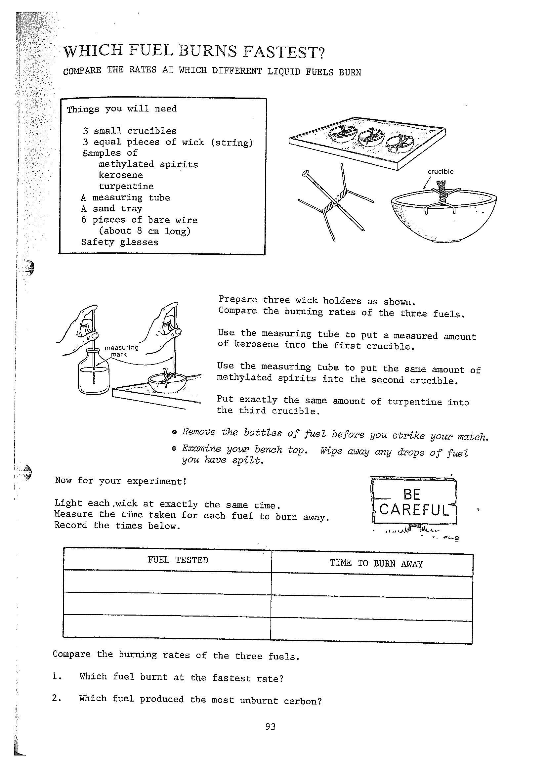
Things you will need for Part (a)

- 4 small crucibles
- 4 equal pieces of wick (string)
- Samples of
*Methylated spirits
*Kerosene
*Turpentine
*Unleaded petrol
- A measuring tube (straw)
- A sand tray/bench mat
- 8 pieces of bare wire(~8cm long)
- Safety glasses
- Match sticks
- Timer

- Prepare four wick holders as shown.
- Use the measuring tube to put a measured amount of each type of fuel into each of the four crucibles.
- Put the same amount of each fuel into the crucibles.

SAFETY
- Remove the bottles of fuel before you strike a match.
- Wipe away any drops of fuel that may have been spilt.
- Wait for the crucible to cool down before you attempt to remove them.

Procedure for Part (a):
Light each of the four wicks at the same time.
Measure the time taken for each fuel to burn away.
Record the times in a table.
Compare the burning rates of the four fuels
- Which fuel burnt at the fastest rate?
- Which fuel produced the most unburnt carbon?

Fuel tested | Time to burn away (min.)

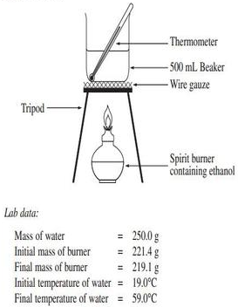
Things you will need for Part (b)

- 4 small crucibles
- 4 equal pieces of wick (string)
- Samples of
*Methylated spirits
*Kerosene
*Turpentine
*Unleaded petrol
- A measuring tube (straw)
- A sand tray/bench mat
- 8 pieces of bare wire(~8cm long)
- Safety glasses
- Match sticks
- 4 thermometers
- 4 beakers(250mL)
- 4 tripods
- 4 gauze mats

Procedure for Part (b):
Place equal amount of water into each of the four 250mL beakers.
Measure the temperature of water in each beaker (initial temperature).
Place the beaker of water on top of a crucible.
Light up the fuel.
When the fuel is spent, measure the temperature of the water (final temperature).

Fuel tested | Temperature change (final – initial) (ΔºC)

Calculations:

Refer to your Task 8 sheet.

